

**HUSACCT**

**Architecture Notebook**

Team 1:

Erik Verhoef 1572690  
René van Aerle 1556647  
Tim Linschoten 1548807  
Niels Nijveldt 1562854  
Stefan Collette 1575795

Teachers: Leo Pruijt, Christian Köppe, Michiel Borkent.

Date: 29-05-2012

Inhoudsopgave

Architectural significant requirements 2

Use cases 2

Use case model 2

Use case New Workspace 3

Use case Open Workspace 5

Use case Save Workspace 7

Use case Close Workspace 9

Use case Define Architecture 10

Use case Defined architecture diagram 11

Use case Import Architecture 12

Use case Export Architecture 13

Use case Application properties 14

Use case Analysed application overview 16

Use case Analysed application diagram 17

Use case Validate 18

Use case Validate configuration 19

Use case Export violation report 20

Use case Change Language 21

Toolbar 22

Taskbar 22

Functional Requirements 23

Non-functional requirements 23

Decisions and justification 24

Physical models 25

Physical class diagram 25

Physical software partitioning model 26

Architectural Rules 27

# Architectural significant requirements

## Use cases

* New Workspace
* Open Workspace
* Save Workspace
* Close Workspace
* Define architecture
* Defined architecture Diagram
* Import architecture
* Export architecture
* Application properties
* Analysed application overview
* Analysed architecture diagram
* Validate
* Validate configuration
* Export violation report
* Change Language

### Use case model



### Use case New Workspace

|  |  |  |
| --- | --- | --- |
| New workspace |  |  |
| Version | 1.0 | |
| Priority | Must have | |
| Actors | User | |
| Summary | The user is able to create a new workspace with new definitions. This workspace can be saved and reopened for later usage. | |
| Precondition | The HUSSAC-tool is opened. | |
| Main scenario | **Actor actions** | **System actions** |
|  | 1. Actor clicks File -> New workspace or types Ctrl + N |  |
|  |  | 1. System shows the ‘New Workspace’-dialog |
|  | 1. Actor fills in the workspace-name |  |
|  | 1. Actor clicks ‘OK’ |  |
|  |  | 1. System creates the workspace |
|  |  | 1. System opens the Define internalframe (see use case Define Architecture) |
| Postcondition | The workspace is created within memory and the Define internalframe is opened. | |
| Alternative scenario | At step 3 |  |
|  | * 1. Actor clicks the ‘set application’ checkbox |  |
|  |  | * 1. System collapses the dialog to show the ‘set application’-form |
|  | * 1. Actor fills in the application properties (see use case Application properties) |  |
|  |  | * 1. System sends the application properties to the Define-service |
|  |  | * 1. System requests the Analyse-service to analyse the application |
| Postcondition AS | The workspace is created within memory and the application is analysed. | |
| Constraints | Both the workspace name and the application name must be alphanumeric, the only special symbols allowed are the dash (‘-‘) and the underscore (‘_’). Workspace and application name may not be empty. | |

#### User interface

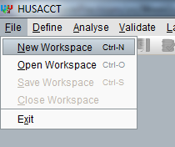

Figure 1. New workspace, step 1

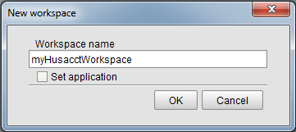

Figure 2. New workspace, step 2

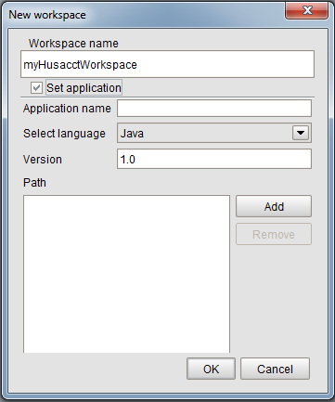

Figure 3. New workspace; alternative scenario step 3.2

### Use case Open Workspace

|  |  |  |
| --- | --- | --- |
| Open workspace |  |  |
| Version | 1.0 | |
| Priority | Must have | |
| Actors | User | |
| Summary | A workspace can be opened from a saved workspace-file. | |
| Precondition | The Husacct-tool is opened and a workspace file exists. | |
| Main scenario | **Actor actions** | **System actions** |
|  | 1. Actor clicks File -> Open workspace or types Ctrl + O |  |
|  |  | 1. System shows the ‘Open Workspace’-dialog |
|  | 1. Actor selects open-method |  |
|  | 1. Actor fills in method-specific information |  |
|  | 1. Actor clicks ‘Open’ |  |
|  |  | 1. System sends workspace-data from file to the appropriate services |
|  |  |  |
| Postcondition | The workspace is opened with the available information loaded. | |
| Alternative scenario 1 | At step 3 |  |
|  | * 1. Actor selects ‘Husacct’ |  |
|  |  | * 1. System shows the ‘open as Husacct-file’-form |
|  | * 1. Actor specifies the location of the Husacct-file |  |
|  |  |  |
| Postcondition AS1 | The workspace is opened with the available information loaded. | |
| Alternative scenario 2 | At step 3 |  |
|  | * 1. Actor selects ‘XML’ |  |
|  |  | * 1. System shows the ‘open as xml-file’-form |
|  | * 1. Actor specifies the location of the xml-file |  |
| Postcondition AS2 | The workspace is opened with the available information loaded. | |
| Transformation rules | The data from the selected open-method is transformed to a xml-document | |

#### User Interface

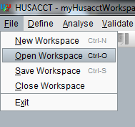

Figure 4. Open workspace; step 1

##### **Alternative scenario 1, step 3.2**

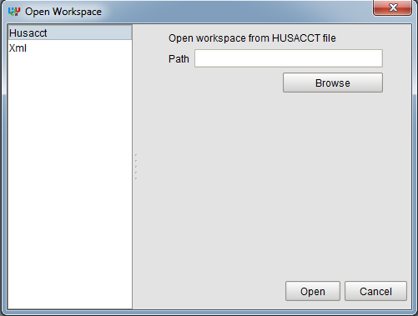

Figure 5. Open workspace; alternative scenario 1, step 3.2

##### **Alternative scenario 2, step 3.2**

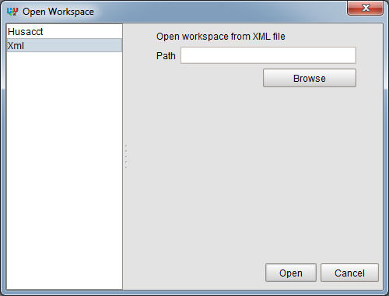

Figure 6. Open workspace; Alternative scenario 2, step 3.2

### Use case Save Workspace

|  |  |  |
| --- | --- | --- |
| Save workspace |  |  |
| Version | 1.0 | |
| Priority | Must have | |
| Actors | User | |
| Summary | The workspace can be saved with the save-method selected by the user. | |
| Precondition | A workspace is created. | |
| Main scenario | **Actor actions** | **System actions** |
|  | 1. Actor clicks File -> Save workspace or types Ctrl + S |  |
|  |  | 1. System shows the ‘Save Workspace’-dialog |
|  | 1. Actor selects save-method |  |
|  | 1. Actor fills in method-specific information |  |
|  | 1. Actor clicks ‘Save’ |  |
|  |  | 1. System collects workspace-data from all services |
|  |  | 1. System saves workspace to the given location |
| Postcondition | The workspace is saved to the location specified by the user with the selected save-method. | |
| Alternative scenario 1 | At step 3 |  |
|  | * 1. Actor selects ‘Husacct’ |  |
|  |  | * 1. System shows the ‘save as Husacct-file’-form |
|  | * 1. Actor specifies the save-location and filename |  |
|  |  |  |
| Postcondition AS1 | The workspace is saved as a Husacct-file (.hu) to the specified location. | |
| Alternative scenario 2 | At step 3 |  |
|  | * 1. Actor selects ‘XML’ |  |
|  |  | * 1. System shows the ‘save as xml-file’-form |
|  | * 1. Actor specifies the save-location and filename |  |
| Postcondition AS2 | The workspace is saved as an XML-file (.xml) to the specified location. | |
| Transformation rules | Internal xml-document is transformed to the format that the selected save-method uses. | |
| Constraints | The filename must be alphanumeric, the only special symbols allowed are the dash (‘-‘) and the underscore (‘_’). Only one dot (‘.’) is allowed in the filename (to prevent filenames like: myWorkspace.xml.xml.xml). Filename may not be empty. | |

#### User Interface

##### **Step 1**

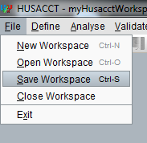

##### **Alternative scenario 1, step 3.2**

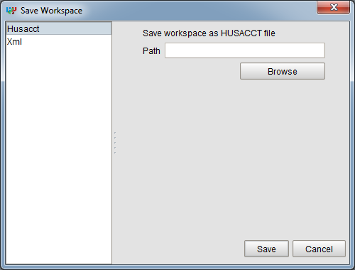

##### **Alternative scenario 2, step 3.2**

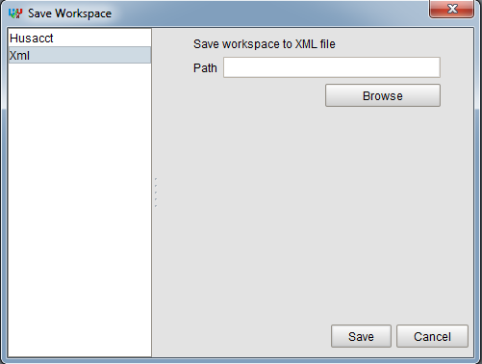

### Use case Close Workspace

|  |  |  |
| --- | --- | --- |
| Close workspace |  |  |
| Version | 1.0 | |
| Priority | Could have | |
| Actors | User | |
| Summary | The workspace can close the workspace. | |
| Precondition | A workspace is open. | |
| Main scenario | **Actor actions** | **System actions** |
|  | 1. Actor clicks File -> Close workspace |  |
|  |  | 1. System closes all opened frames |
|  |  | 1. System resets all services |
| Postcondition | The workspace is closed. | |

#### User interface

##### **Step 1**

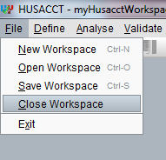

### Use case Define Architecture

|  |  |  |
| --- | --- | --- |
| Define architecture |  |  |
| Version | 1.0 | |
| Priority | Must have | |
| Actors | User | |
| Summary | The user can define a logical architecture then map an application to it. | |
| Precondition | A workspace is open. | |
| Main scenario | **Actor actions** | **System actions** |
|  | 1. Actor clicks Define -> Define architecture or types Ctrl + D |  |
|  |  | 1. System makes a request for the ‘Define architecture’ internalframe from the Define-service |
|  |  | 1. System opens the ‘Define architecture’ internalframe |
| Postcondition | The ‘Define architecture’ internalframe is opened. | |

#### User interface

##### **Step 1**

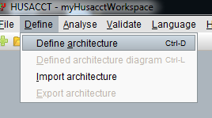

##### **Postcondition**

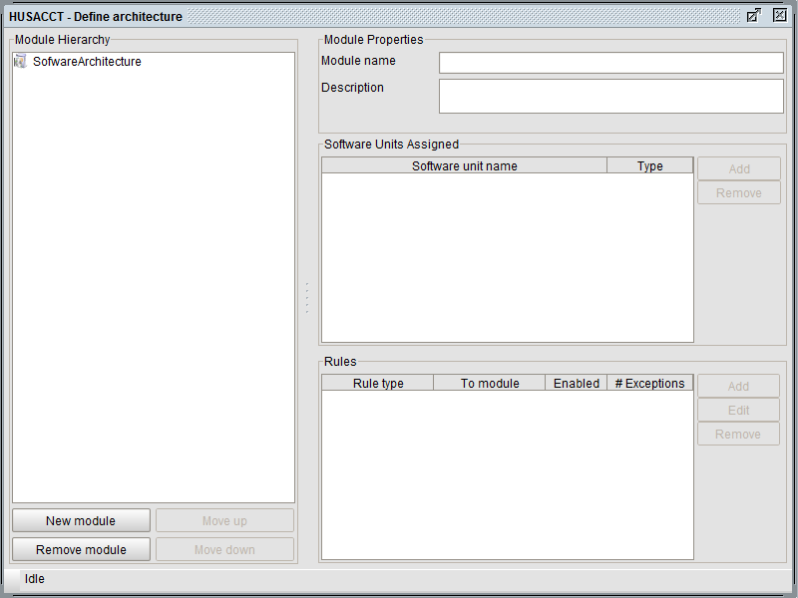

### Use case Defined architecture diagram

|  |  |  |
| --- | --- | --- |
| Defined architecture diagram |  |  |
| Version | 1.0 | |
| Priority | Must have | |
| Actors | User | |
| Summary | The user is able to open a graphical view of the defined architecture | |
| Precondition | A workspace is open, the architecture is defined. | |
| Main scenario | **Actor actions** | **System actions** |
|  | 1. Actor clicks Define -> Defined architecture diagram or types Ctrl + L |  |
|  |  | 1. System makes a request for the ‘Defined architecture diagram’ internalframe from the Graphics-service |
|  |  | 1. System opens the ‘Defined architecture diagram’ internalframe |
| Postcondition | The ‘Defined architecture diagram’ internalframe is opened. | |

#### User interface

##### **Step 1**

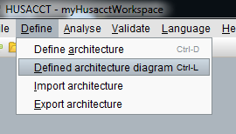

##### **Postcondition**

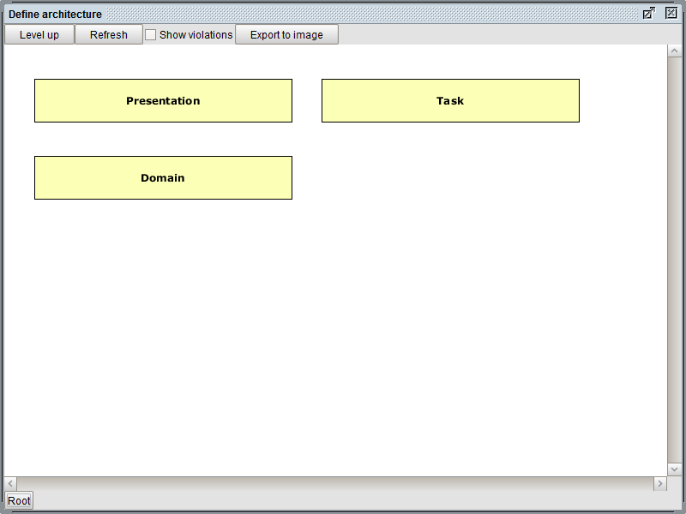

### Use case Import Architecture

|  |  |  |
| --- | --- | --- |
| Import architecture |  |  |
| Version | 1.0 | |
| Priority | Must have | |
| Actors | User | |
| Summary | The user is able to import previously defined architecture. | |
| Precondition | A workspace is open. | |
| Main scenario | **Actor actions** | **System actions** |
|  | 1. Actor clicks Define -> Import architecture |  |
|  |  | 1. System shows ‘Import architecture’-dialog |
|  | 1. Actor specifies the location of the file |  |
|  | 1. Actor clicks ‘Import’ |  |
|  |  | 1. System transforms selected file to an xml-document |
|  |  | 1. System sends xml-document to Define-service |
| Postcondition | The Define-service processes xml-document. | |
| Transformation rules | System transforms selected file content to an xml-document. | |
| Constraints | The selected file must be .xml. | |

#### User interface

##### **Step 1**

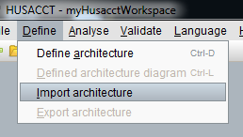

##### **Step 2**

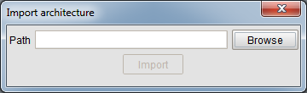

### Use case Export Architecture

|  |  |  |
| --- | --- | --- |
| Export architecture |  |  |
| Version | 1.0 | |
| Priority | Must have | |
| Actors | User | |
| Summary | The user is able to export defined architecture. | |
| Precondition | A workspace is open, architecture is defined. | |
| Main scenario | **Actor actions** | **System actions** |
|  | 1. Actor clicks Define -> Export architecture |  |
|  |  | 1. System shows ‘Export architecture’-dialog |
|  | 1. Actor specifies the location of the file |  |
|  | 1. Actor clicks ‘Export’ |  |
|  |  | 1. System requests the architecture definition from the Define-service as xml-document |
|  |  | 1. System saves xml-document to specified location |
| Postcondition | The architecture is saved to an xml-file at the specified location. | |
| Constraints | The filename must be alphanumeric, the only special symbols allowed are the dash (‘-‘) and the underscore (‘_’). Only one dot (‘.’) is allowed in the filename (to prevent filenames like: myWorkspace.xml.xml.xml). Filename may not be empty. | |

#### User interface

##### **Step 1**

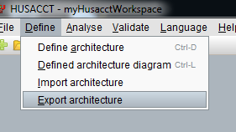

##### **Step 2**

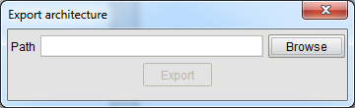

### Use case Application properties

|  |  |  |
| --- | --- | --- |
| Application properties |  |  |
| Version | 1.0 | |
| Priority | Must have | |
| Actors | User | |
| Summary | The user is able to specify the application properties | |
| Precondition | A workspace is open, architecture is defined. | |
| Main scenario | **Actor actions** | **System actions** |
|  | 1. Actor clicks Analyse -> Application properties |  |
|  |  | 1. System shows ‘Application properties’-dialog |
|  | 1. Actor specifies the name, programming language, versionnumber and path of the application |  |
|  | 1. Actor clicks ‘Save’ |  |
|  |  | 1. System sends the application properties to the Define-service |
|  |  | 1. System requests the Analyse-service to analyse the application |
| Postcondition | The application is analysed and the application properties are saved. The application can be mapped to the defined architecture. | |
| Constraints | The application name must be alphanumeric, the only special symbols allowed are the dash (‘-‘) and the underscore (‘_’). The application name may not be empty. | |

#### User interface

##### **Step 1**

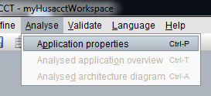

##### **Step 2**

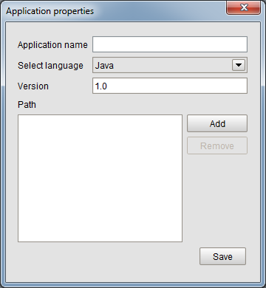

### Use case Analysed application overview

|  |  |  |
| --- | --- | --- |
| Analysed application overview |  |  |
| Version | 1.0 | |
| Priority | Must have | |
| Actors | User | |
| Summary | The user can show an overview of the analysed application. | |
| Precondition | A workspace is open, architecture is defined and an application is analysed. | |
| Main scenario | **Actor actions** | **System actions** |
|  | 1. Actor clicks Analyse -> Analysed architecture overview or types Ctrl + T |  |
|  |  | 1. System makes a request for the ‘Analysed architecture overview’ internalframe from the Analyse-service |
|  |  | 1. System opens the ‘Analysed architecture overview’ internalframe |
| Postcondition | The ‘Analysed architecture overview’ internalframe is opened. | |

#### User interface

##### **Step 1**

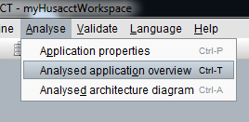

##### **Postcondition**

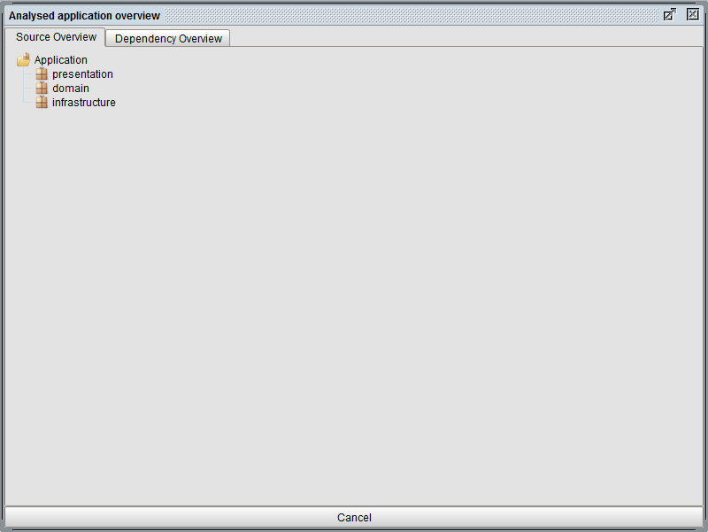

### Use case Analysed application diagram

|  |  |  |
| --- | --- | --- |
| Analysed application diagram |  |  |
| Version | 1.0 | |
| Priority | Must have | |
| Actors | User | |
| Summary | The user can show a graphical view of the analysed application. | |
| Precondition | A workspace is open, architecture is defined and an application is analysed. | |
| Main scenario | **Actor actions** | **System actions** |
|  | 1. Actor clicks Analyse -> Analysed architecture diagram or types Ctrl + A |  |
|  |  | 1. System makes a request for the ‘Analysed architecture diagram’ internalframe from the Analyse-service |
|  |  | 1. System opens the ‘Analysed architecture diagram’ internalframe |
| Postcondition | The ‘Analysed architecture diagram’ internalframe is opened. | |

#### User interface

##### **Step 1**

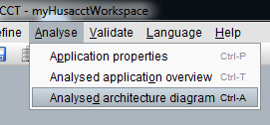

##### **Postcondition**

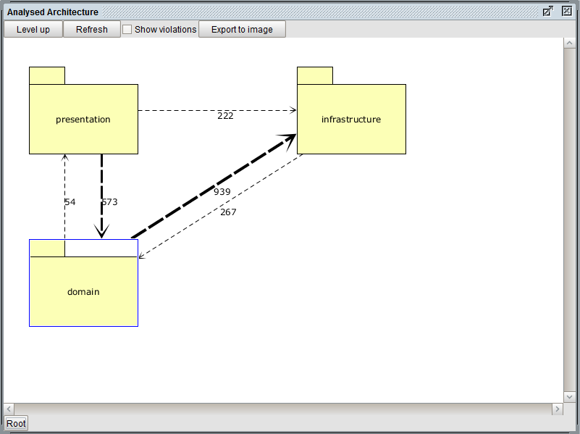

### Use case Validate

|  |  |  |
| --- | --- | --- |
| Validate |  |  |
| Version | 1.0 | |
| Priority | Must have | |
| Actors | User | |
| Summary | The user can validate an application. | |
| Precondition | A workspace is open, architecture is defined, an application is analysed and mapped to the architecture. | |
| Main scenario | **Actor actions** | **System actions** |
|  | 1. Actor clicks Validate -> Validate now or types Ctrl + V |  |
|  |  | 1. System makes a request for the ‘Violations’ internalframe from the Validate-service |
|  |  | 1. System opens the ‘Violations’ internalframe |
| Postcondition | The ‘Violations’ internalframe is opened. | |

#### User Interface

##### **Step 1**

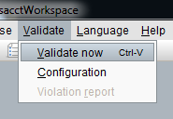

##### **Step 3**

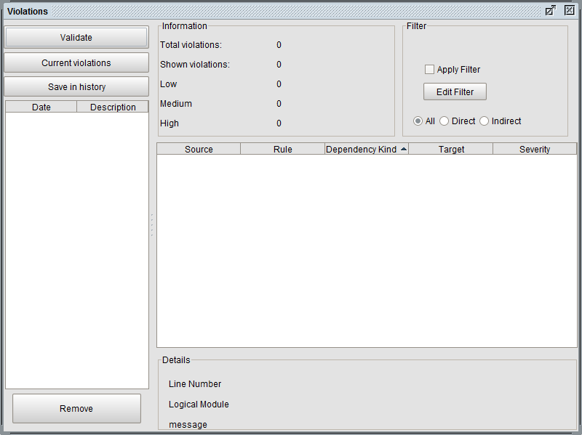

### Use case Validate configuration

|  |  |  |
| --- | --- | --- |
| Validate configuration |  |  |
| Version | 1.0 | |
| Priority | Must have | |
| Actors | User | |
| Summary | The user can configure the violations and the way they are shown. | |
| Precondition | A workspace is open. | |
| Main scenario | **Actor actions** | **System actions** |
|  | 1. Actor clicks Validate -> Configuration |  |
|  |  | 1. System makes a request for the ‘Configuration’ internalframe from the Validate-service |
|  |  | 1. System opens the ‘Configuration’ internalframe |
| Postcondition | The ‘Configuration’ internalframe is opened. | |

#### User Interface

##### **Step 1**

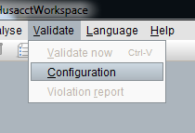

##### **Step 3**

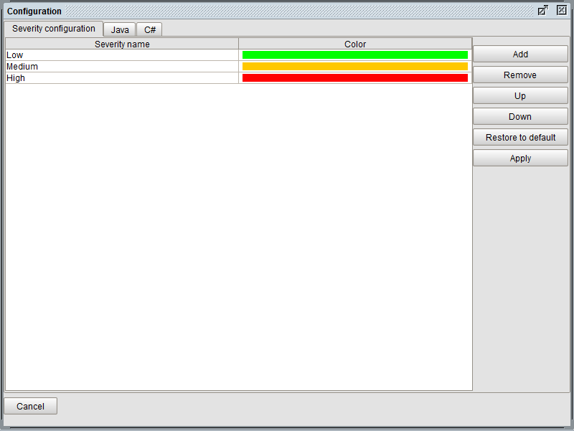

### Use case Export violation report

|  |  |  |
| --- | --- | --- |
| Export violation report |  |  |
| Version | 1.0 | |
| Priority | Must have | |
| Actors | User | |
| Summary | The user can export the violations. | |
| Precondition | A workspace is open, architecture is defined, an application is analysed and mapped to the architecture. The application is validated. | |
| Main scenario | **Actor actions** | **System actions** |
|  | 1. Actor clicks Validate -> Export violation report |  |
|  |  | 1. System show the ‘Export violation report’-dialog |
|  | 1. Actor clicks ‘Browse’ |  |
|  |  | 1. System makes a request for the filetypes from the Validate-service |
|  | 1. Actor specifies the location of the file and specifies the filetype |  |
|  | 1. Actor clicks ‘Export’ |  |
|  |  | 1. System sends the file and file-extension to the Validate-service |
| Postcondition | The Validate-service creates a report and saves the report to the specified location. | |
| Constraints | The filename must be alphanumeric, the only special symbols allowed are the dash (‘-‘) and the underscore (‘_’). Only one dot (‘.’) is allowed in the filename (to prevent filenames like: myReport.pdf.html.xml). Filename may not be empty. | |

#### User Interface

##### **Step 1**

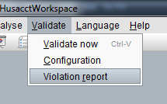

##### **Step 3**

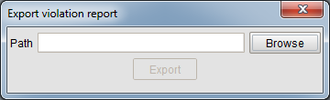

### Use case Change Language

|  |  |  |
| --- | --- | --- |
| Validate configuration |  |  |
| Version | 1.0 | |
| Priority | Must have | |
| Actors | User | |
| Summary | The user can change the language the application is in. | |
| Precondition | The Husacct-tool is opened. | |
| Main scenario | **Actor actions** | **System actions** |
|  | 1. Actor clicks Language -> Language that isn’t selected |  |
|  |  | 1. System checks the values with the appropriate resourcefile |
|  |  | 1. System notifies the listeners of the Locale-service |
|  |  | 1. System changes the language of the GUI |
| Postcondition | The language of the GUI is changed. | |

#### User interface

##### **Step 1**

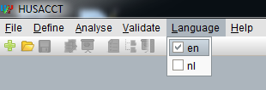

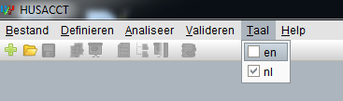

### Toolbar

A toolbar is implemented to increase the ease of use of the HUSACCT-tool. All the buttons in the toolbar are directly linked to the items in the menubar.



The buttons are from left to right:

* New workspace
* Open workspace
* Save workspace
* Define architecture
* Defined architecture diagram
* Application properties
* Analysed application overview
* Analysed application diagram
* Validate

### Taskbar

The taskbar is shown when an internalframe is opened. The taskbar is implemented to give a clear overview of all the opened internalframes.

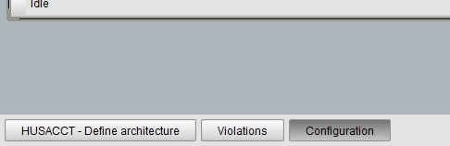

Left-click on a button will put the corresponding frame to the front.

Right-click on a button will open a contextmenu.

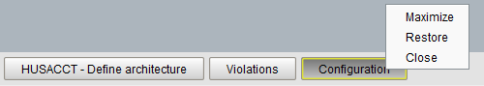

Maximize, maximizes the frame.  
Restore, sets the size of the frame to the default and centers the frame.  
Close, close the frame.

## Functional Requirements

|  |  |  |
| --- | --- | --- |
| **CFR** | **Description** | **Priority** |
| 1 | Ability to call the define service. This service is responsible to handle several operations which has to do with defining architecture rules. | Must have |
| 2 | Ability to call the analyse service. This service is responsible to handle several operations which has to do with analyzing. | Must have |
| 3 | Ability to call the validate service. This service is responsible to handle several operations which has to do with validating. | Must have |
| 4 | Ability to save project. | Must have |
| 5 | Ability to close project. | Should have |
| 6 | Ability to open project. | Must have |
| 7 | Ability to open a specific view | Should have |
| 8 | Ability to close a specific view. | Should have |
| 9 | Ability to create a new project. | Must have |
| 10 | Ability to show the architectural graphics. | Must have |

## Non-functional requirements

|  |  |  |
| --- | --- | --- |
| **NFR** | **ISO 9123 attr.** | **Requirement** |
| **1.** | **Functionality** |  |
| 1.1 | Suitability | Configuration of the user language must be possible. |
| 1.2 | Interoperability | Communication with other applications (Maven, Sonar, Ant ...) must be supported. E.g. activate, import; export. |
|  | **Reliability** |  |
|  | Maturity | The tool must not go down in case of a failure, but generate a meaningful error message. |
|  | **Usability** |  |
|  | Understandability | The division in required steps (manual and automated) must be clear to the user of the tool. |
|  | Understandability | It must be clear to the user what he/she is working on |
|  | **Maintainability** |  |
|  | Analyseability  Testability | Taking over the development of the tool by other development teams must be unproblematic. |
|  | **Portability** |  |
|  | Adaptability | Plug-ins for IDE’s (Eclipse, Sonar ...) must be provided. |
|  | Installability | The tool must be easy to install. |
|  | Installability | The tool must provide a complete installation package (no extra downloads needed). |
| 4.4 | Adaptability | The tool must be usable in several operating systems. |

## Decisions and justification

|  |  |
| --- | --- |
| **Decision** | **Justification** |
| In order to ensure the user language of the SACC-tool is independent, we will  use ResourceBundles in Java. We will implement the observer pattern to notify the other services of a language change. | NF1.1 |
| In order to ensure other development teams can easily maintain the source code of the SACC-tool, we make use of GIT combined with GITHUB. | NF4.1 |
| In order to ensure the SACC-tool is operating system independent, we develop  the GUI in Java Swing. | NF5.4 |
| To support plugin development based on the tool, the presentation and task layer are separated. | NF1.2 |
| Services can call a method to display error and/or info messages on top of the main gui | NF2.1 |
| The system keeps track of the state of the workspace, making sure that buttons are enabled/disabled at the appropriate state | NF3.1 |
| Libraries are included within the project, groups/services and testsuites are separated in packages, build scripts are all relative. This ensures that when importing the project in eclipse that all dependencies are met. | NF4.1 |
| The tool is packaged including all dependencies | NF5.2 NF5.3 |
| It was decided not to use a tabbed panes because it wasn't possible to show several windows at once. Instead a taskbar was implemented to give an overview of the opened frames. | NF3.2 |
| JDOM2 was chosen for its ease in use and the ability to merge multiple elements into one document when saving the workspace. | FR 4 FR 6 |

# Physical models

## Physical class diagram

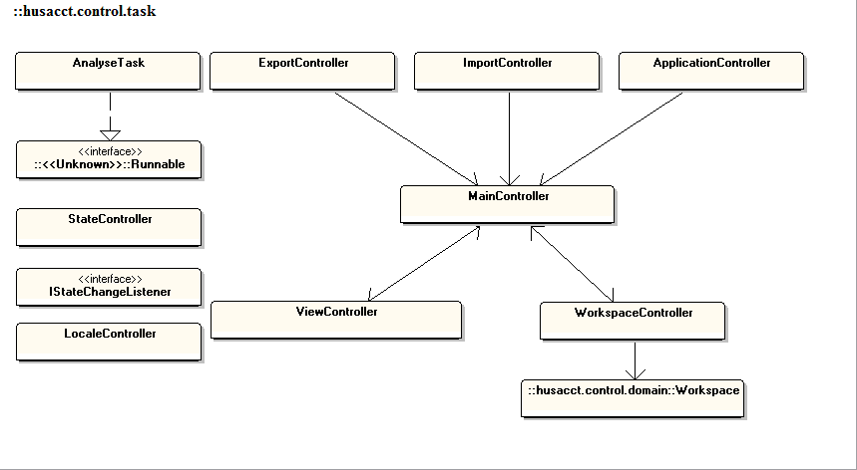

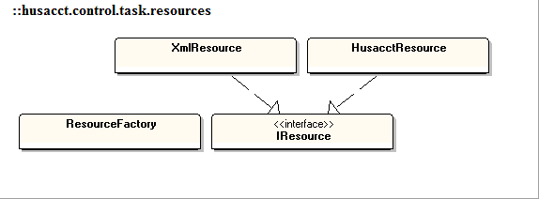

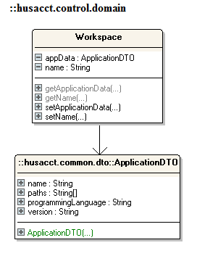

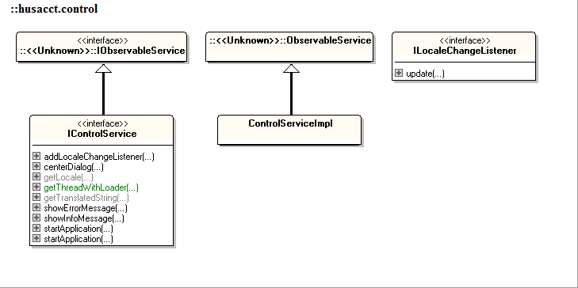

## Physical software partitioning model



## Plugin component diagram

## 

### Architectural Rules

|  |  |  |
| --- | --- | --- |
|  | **Rules on the contents of a module** | Restricts the contents of a module |
|  | A module can have only one parent | - |
|  | No loops in the module hierarchy | - |
|  | Unique responsibility | - |
|  | Visibility convention | Only the interfaces are visible to the other services. |
|  | Naming convention | - |
|  | Subclass convention | - |
|  | Interface convention | - |
|  | **Rules on the legality of Dependency** |  |
|  | Is allowed to use | View is allowed to use Controller and Controller is allowed to use View  Controller is allowed to use Define, Analyse, Validate and Architecture Graphics Interfaces |
|  | Is only allowed to use | - |
|  | Is the only module allowed to use | - |
|  | Must use | - |
|  | Is not allowed to | Define, Analyse, Validate and Architecture Graphics are not allowed to use Controller |
|  | … use modules in higher layer | - |
|  | … use modules in a not directly lower layer | - |
|  | Exceptions to all those rules | Define, Analyse, Validate and Architecture Graphics are allowed to give an Exception to Controller or to add an observer to LocaleService. |
|  | **Rules on Dependency Limitation** |  |
|  | Publish Subscribe pattern (or Observer) | Observer pattern is implemented. The LocaleService is the Observerable and the other services have their own observer.  A notify to the observers is send when the user language has been changed in the GUI. |
|  | Facade pattern | The different services(Define, Analyse, Validate and Architecture Graphics) do have a façade(interface) which the controller communicates with. |
|  | Data Transfer Object | - |
|  | Error messages conform X | When an export or import fails an Exception is sent to us by the appropriate service. |
|  | Communication protocol conform Y | When an export or import succeeds we get a message (Boolean) confirming the import/export. |
|  | No cycles in the dependency | - |